**Ahmad El Rouby**

**900143559**

**Spring 2018**

**Machine Learning**

**Assignment 1 Report**

**Part 1**

1. Source code is attached
2. This is the result of Tuning the K value and L(L1 and L2)

Average Accuracy for L: L1, K: 1, is 29.8598598599%

Standard Deviation for L: L1, K: 1, is 0.00548453554827

Average Accuracy for L: L1, K: 2, is 27.2072072072%

Standard Deviation for L: L1, K: 2, is 0.0023390032924

Average Accuracy for L: L1, K: 3, is 29.4694694695%

Standard Deviation for L: L1, K: 3, is 0.00187270139478

Average Accuracy for L: L1, K: 5, is 30.5305305305%

Standard Deviation for L: L1, K: 5, is 0.000990940434095

Average Accuracy for L: L1, K: 7, is 30.960960961%

Standard Deviation for L: L1, K: 7, is 0.0057815932245

Average Accuracy for L: L1, K: 9, is 30.6106106106%

Standard Deviation for L: L1, K: 9, is 0.00503295499098

Average Accuracy for L: L1, K: 12, is 30.8408408408%

Standard Deviation for L: L1, K: 12, is 0.00830408614693

Average Accuracy for L: L1, K: 15, is 30.7707707708%

Standard Deviation for L: L1, K: 15, is 0.00953528985314

Average Accuracy for L: L2, K: 1, is 27.4374374374%

Standard Deviation for L: L2, K: 1, is 0.0072002524558

Average Accuracy for L: L2, K: 2, is 25.1251251251%

Standard Deviation for L: L2, K: 2, is 0.00123411691751

Average Accuracy for L: L2, K: 3, is 26.956956957%

Standard Deviation for L: L2, K: 3, is 0.0027559359155

Average Accuracy for L: L2, K: 5, is 27.987987988%

Standard Deviation for L: L2, K: 5, is 0.00171635917913

Average Accuracy for L: L2, K: 7, is 28.4484484484%

Standard Deviation for L: L2, K: 7, is 0.000928290139689

Average Accuracy for L: L2, K: 9, is 28.4384384384%

Standard Deviation for L: L2, K: 9, is 0.00371046105963

Average Accuracy for L: L2, K: 12, is 28.4284284284%

Standard Deviation for L: L2, K: 12, is 0.0059926444633

Average Accuracy for L: L2, K: 15, is 27.5275275275%

Standard Deviation for L: L2, K: 15, is 0.00556073850344

**The Best Parameters where K being 7 and L as L1.**

**The Graph**

(L1 is red and L2 is Blue)

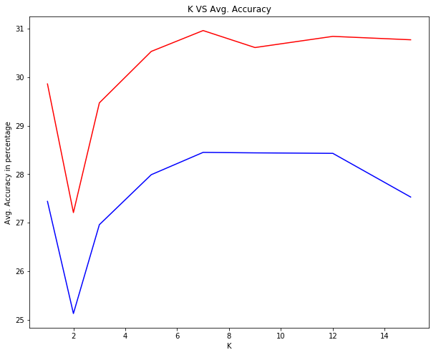

1. **CCRN for the 10K Test Set:**

Got 3217 / 10000 correct => accuracy: 0.321700

1. **ACCR for the 10K Test Set:**

Class: 0 ( plane ) , accuracy: 0.559

Class: 1 ( car ) , accuracy: 0.201

Class: 2 ( bird ) , accuracy: 0.427

Class: 3 ( cat ) , accuracy: 0.185

Class: 4 ( deer ) , accuracy: 0.411

Class: 5 ( dog ) , accuracy: 0.193

Class: 6 ( frog ) , accuracy: 0.259

Class: 7 ( horse ) , accuracy: 0.192

Class: 8 ( ship ) , accuracy: 0.635

Class: 9 ( truck ) , accuracy: 0.155

**Part 2**

1. Source code is attached.
2. How I calculated the W

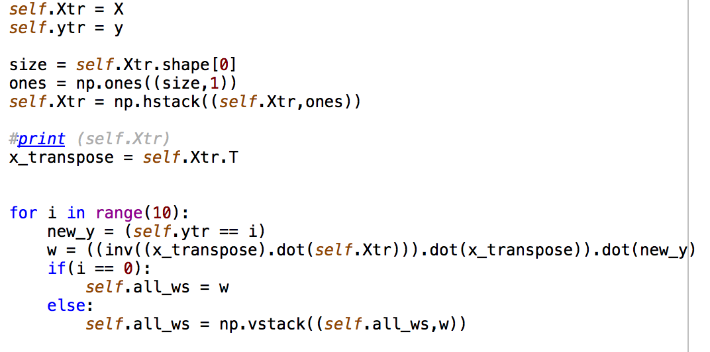

1. **CCRN for the 10K Test Set:**

Class: 0 ( plane ) , accuracy: 0.469

Class: 1 ( car ) , accuracy: 0.445

Class: 2 ( bird ) , accuracy: 0.207

Class: 3 ( cat ) , accuracy: 0.177

Class: 4 ( deer ) , accuracy: 0.243

Class: 5 ( dog ) , accuracy: 0.285

Class: 6 ( frog ) , accuracy: 0.449

Class: 7 ( horse ) , accuracy: 0.426

Class: 8 ( ship ) , accuracy: 0.508

Class: 9 ( truck ) , accuracy: 0.428

1. **ACCR for the 10K Test Set:**

Got 3637 / 10000 correct => accuracy: 0.363700

1. Training Set Accuracy:

Got 25472 / 50000 correct => accuracy: 0.509440

Since there’s no big difference in accuracy between the Test Set and Training Set, I don’t think there was an overfitting of the data.